**Works Manager Online**

An internet based application to monitor building projects contracts of the

Department of Logistics and Supply of the

Nigeria Police Force



**Works Manager Online**

**Training Manual**

**January 2020**

By Dr. Taofeek Oladiran Folami

Email: [drfolami@yahoo.co.uk](mailto:drfolami@yahoo.co.uk), [drfolami@nasniconsultants.com](mailto:drfolami@nasniconsultants.com)

Nasni Consultants Limited, 28 Bode Thomas Street, Surulere, Lagos.

[www.nasniconsultants.com](http://www.nasniconsultants.com);

# Table of Contents

Table of Contents i

1 Introduction 1

1.1 About Works Manager Online 1

1.2 Works Manager Online Training Topics 1

1.3 Guidelines and Terminologies 2

2 Getting to Works Manager Online Site 3

2.1 How to get to the site 3

2.2 How to navigate around the site 3

2.3 Site Headers, Menu, Body, Buttons, Links, Footer and the Search engine 3

3 The Public Engagement Blog 6

3.1 Introducing the Public Engagement Blog 6

3.2 Navigate the Public Engagement Blog 6

3.3 Submit a post on Latest Events, Upcoming Events and Bulletins 6

3.4 Search for posts 7

3.5 Recent Post, Recent Comments and Tags cloud 7

3.6 Edit an existing post 7

3.6.1 Make a Post Featured 8

3.6.2 Make a Post Sticky 8

3.7 Upload additional images and files to an existing post 8

3.8 Overview on navigating a website 8

4 User Registration 9

4.1 Introducing User Registration 9

4.2 Register a User for Works Manager Online Operations 9

4.3 Log in as a Registered User 10

4.4 Edit the profile of a registered user 10

4.5 Log out of the site. 10

4.6 Rules of User Engagement 11

5 Command and Zone Assignments 12

5.1 The purpose of Command and Zone Assignments 12

5.2 Assign a User to a Command 13

5.3 Assign a User to a Zone 13

5.4 Remove a User from a Command 14

5.5 Remove a User from a Zone 14

5.6 Remove a User from all Commands 14

5.7 Remove a User from all Zones 15

5.8 Overview of Command and Zones Assignments 15

6 Role Assignments 16

6.1 Concept of Role Assignments 16

6.2 Add Role to a User 17

6.3 Remove Role from a User 17

6.4 Remove all Roles from a User 17

6.5 Overview of Role Assignments – The required credentials 18

7 Operational Data 19

7.1 Introducing the Operational Data concept 19

7.2 Description of Works 19

7.3 Land Status 20

7.4 Recommendations 20

7.5 Site Incidents 20

7.6 Site Issues 20

7.7 Site Status 21

7.8 Upload Contracts Information to Works Manager Online Website 21

7.9 Review of Operational Data 21

8 The Contracts Blog and The Reports Blog 22

8.1 Contracts Blog and Reports Blog Explained 22

8.2 Contracts Blog 22

8.3 Contract Post 22

8.4 Contract Post's Reports Templates 22

8.5 Search Contracts – Basic Search and Advanced Search engines 23

8.5.1 Basic Contracts Search 23

8.5.2 Advanced Contract Search 23

8.6 Contracts Assigned to a Registered User 24

8.7 Reports Blog 24

8.8 Report Post 24

8.9 Search Reports 24

8.10 Review of Contracts and Reports Blog 25

9 Monitoring the Progress of Contracts – Submitting Reports on Contracts 26

9.1 Recap of the motivation for Works Manager Online. 26

9.2 Submit Monthly Progress Report 26

9.3 Submit Site Report 27

9.4 Submit Interim Report 27

9.5 Submit Incident Report 28

9.6 Submit Investigation Report 29

9.7 Submit Completion Report 29

9.8 Submit Land Acquisition Report 30

9.9 Submit Special Visits Report 30

9.10 Review of Monitoring the Progress of Contracts 31

10 Archives 32

10.1 Site-Wide Archives 32

11 Appendix 33

11.1 About Us 33

11.2 Contact Us 33

11.3 Your Feedback 33

11.4 License 33

11.5 Privacy Policy 33

11.6 Vendor and Credits 33

11.7 Frequently Asked Questions (FAQs) 33

11.7.1 How do I see my contracts? 33

11.7.2 What do I do if I cannot remember my user name and password? 33

11.7.3 What do I do if some of my contracts are not listed? 33

11.7.4 Why can I not submit reports for contracts assigned to me? 33

11.7.5 How can I block a user totally from gaining any form of access to Works Manager Online? 33

# Introduction

## About Works Manager Online

**Works Manager** an enterprise windows based desktop application deployed at the Department of Logistics and Supply (DLS) of the Nigeria Police Force (NPF) for managing information on biding, award, monitoring, assessment and payments recommendation on infrastructure contracts. Features in the application allow staff to create, modify and generate relevant reports and documentation pertinent to the contracts awarded and supervised. Key documents of relevance include Contractors Details, Contracts Details, Schedules of Payment, Contract Award Letters, Due Process Certificates (Awards, Payments), Interim Certificates and Payment Vouchers. These documents are created in strict order in compliance with standard procedures and practices in supervision and management of contracts in the Nigeria Police Force.

**Works Manager Online** is a web based application extending these tools for managing infrastructure projects by providing Internet based features. **Works Manager Online** serves two main purposes. The first is as a **public engagement blog** that enables DLS engage effectively with key stakeholders and the public in general, with the view to educate and sensitise the public, and, above all, get valuable feedback on the impact of the projects initiated in various communities. The second purpose is as a **project monitoring tool** for management and project supervisory staff to effectively the progress of the contracts across the various commands and zones by transmitting information (pictures, videos, documents) via the internet. One of the expected outcomes improved project delivery cycles.

Technically, **Works Manager Online** is **a website hosting a customised application** with features for monitoring the progress of construction and rehabilitation contracts awarded by the Nigeria Police Force and supervised by its Department of Logistics and Supply. From any site location in any command or zones, project officers can take pictures and videos of activities and submit them online with concise descriptions (via predefined form templates) on the website. This provides the management of the Nigeria Police Force with a powerful tool to monitor the progress of all their contracts online from a central website.

**Works Manager** **Online** gets the contracts details from the Works Manager desktop application on which contract details and award documentation are stored. When a contract is awarded to a contractor, the details of that contract stored Works Manager are then uploaded to the **Works Manager Online** website ready for monitoring the progress of the contract from when the contractor moves to site to its completion.

**Works Manager** **Online** is built with WordPress, a popular content management system used by more than 60million websites today (as at 2020). If you have used Facebook, WhatsApp, online newspapers, attached documents such as photographs and reports to your email and sent to a recipient, and then Works Manager Online will be familiar to you. The main difference is that the subject matter concerns the contracts given out by NPF through the Department of Logistics and Supply. The details of all the contracts would have been uploaded unto the website and you will be required only to input and submit your progress reports on each contract through the website, including pictures, videos and documents.

## Works Manager Online Training Topics

This document serves both as a training manual and a user manual for using Works Manager Online. The sessions, or topics, are broadly categorised as Getting to the Site, Managing the Public Engagement Blog, User Management, Command and Zone Assignments, Role Assignments, Operation Data, Contracts and Reports, Managing the Progress of Contracts and Archiving. These sessions cover the visitors, operational, administrative and supervisory roles of the website.

Administrators/Supervisors focus on User Management, Command and Zone Assignments, Role Assignments and Operation Data. Works Officers and Project Officers tasked with site monitoring of contracts will be primarily concerned with Contracts & Reports and Managing the Progress of Contracts. Other visitors to the site can engage only via the Public Engagement Blog.

## Guidelines and Terminologies

This document describes how to use Works Manager Online.

The words **page, post, article, media, image, blog, blog list, links or hyperlinks, sliders, featured, sticky, url, menu, footer, header, sidebar, buttons, tabs, icon, scroll, scrollbar** and **forms** are web browsing terminologies describing the visual displays on the browser that users interact with; they will be used freely and interchangeably in this document.

Since Works Manager Online is basically a content management system (CMS) website dealing, each contract details, or report details, is a **post** that represents an **article** posted to the site; The contracts (or reports) list is a **blog** list.

A **browser** is the primary means to interact with websites on the Internet. Popular modern web browsers include Google Chrome, Mozilla Firefox, Opera, Internet Explorer and Safari. You can use any of these browsers to launch Works Manager Online website and perform relevant tasks.

Your browser displays a single **page** at a time, and the page can contain all types of content such as text, graphics, images and videos, and they can be formatted accordingly.

The **scrollbar** is a bar at the right of the page you use to move up and down, scroll up and down, the page

**Featured** posts are a collection of posts that you want to attract the attention of users’ and they are, typically, displayed in separate but locations such as sidebars and sliders.

**Featured image** of a post is the image embedded in the blog list of the post and is intended to communicate the context and subject of the post.

**Sticky** posts are always pushed to the top of the blog list regardless of the display order defined for the list.

**To quickly grasp the concepts and topics presented in this document, it is recommended that you launch a tutorial session of Works Manager Online using you preferred browser in parallel to studying this document.**

# Getting to Works Manager Online Site

## How to get to the site

Works Manager on line is located on the web at this address, <https://npfworksmanager.com>; this is the URL of the website, and is unique to the site. Click the link to go to the site or alternatively open you preferred web browser (Google Chrome, Opera, and FireFox etc) and type <https://npfworksmanager.com>, or just [npfworksmanager.com](https://npfworksmanager.com), in the address bar of your browser.

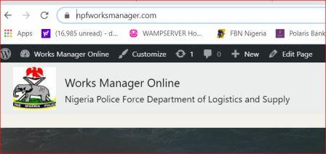

You will be taken to, or served with, the Works Manager Online website **home** **page**, or **landing page,** as it is sometimes called. You will land at the Public Engagement Blog designed for all visitors to the site, as shown in the snippet below.

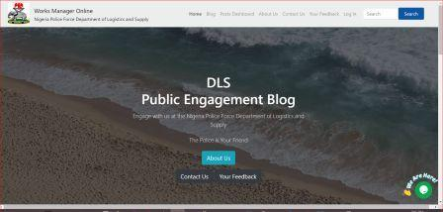

If you are a registered user and you are logged in, the landing page changes to the screenshot below.

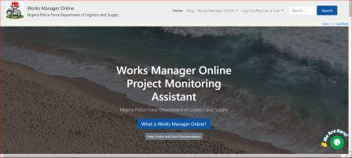

## [How](https://npfworksmanager.com/works-manager-online/navigate-the-site/) to navigate around the site

You will navigate around the site by selecting options from the menu bar at the top of the page and/or by clicking hyperlinks around the page to take you to the page you want.

## Site Headers, Menu, Body, Buttons, Links, Footer and the Search engine

In general, the typical elements on a website page are listed in the table below.

|  |  |
| --- | --- |
| The Menu bar: | The Header: |
| The Sidebar | Footer |
| Blog | Recent Posts |
| Categories | Tags |
| Archives | Search box |
| Links | Feedback |
| Contact Us | Scroll to Top |

Each of these elements contains links to help you navigate the site. This is typical of modern websites.

Screenshots on next page illustrates some of these elements.

**Screenshots of typical page of the site**

C:\Users\drfol\AppData\Local\Microsoft\Windows\INetCache\Content.Word\Menu in Header.png

Menu bar

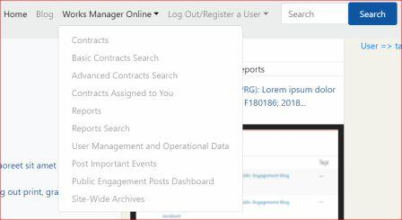

Menu

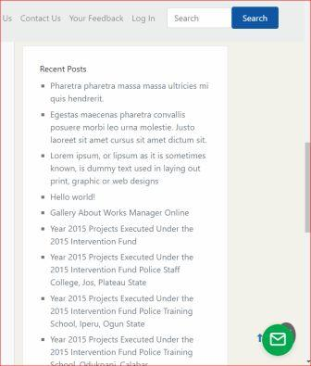

Sidebar

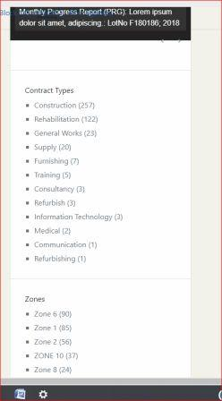

Sidebar

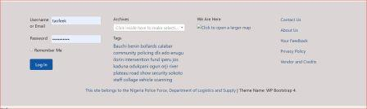

Footer

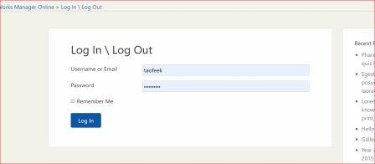

Login Form

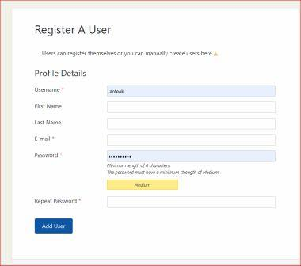

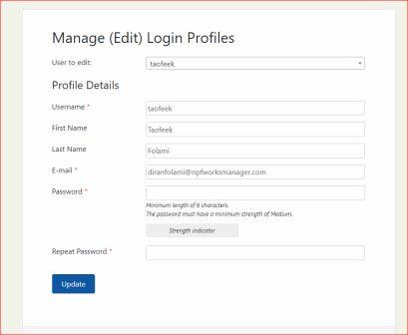

We will assume you have launched the website by now, so we will not insert images and screenshots into all sections of this document in subsequent sections.

# The Public Engagement Blog

## Introducing the Public Engagement Blog

When you launch Works Manager Online by typing [https://npfworksmanager.com](https://npfworksmanager.com/) in the browser’s address bar, you will land at the **Public Engagement Blog** home page.

The **Public Engagement Blog** enables DLS engage effectively with key stakeholders and the public in general, with the view to educate and sensitise the public, and, above all, get valuable feedback on the impact of the projects initiated in various communities.

Scroll down to view the rest of the page to see other links and content shown on the page. Click a link or a button on the page to go to the subject you desire. In many cases, however, you will navigate via the menu bar at the top of the page.

## Navigate the Public Engagement Blog

To see the list of posts of the blog, click **Blog** on the menu bar. If you are a registered user and have logged in, click **Works Manager Online** on the menu bar, then select **Contracts** to see the list of contracts

The convention for navigation by menu is **Menubar item => Menu Option => Sub-Menu Option e.t.c**.

Therefore, to display the list of contracts navigate Works Manager Online => Contracts

## Submit a post on Latest Events, Upcoming Events and Bulletins

* Navigation: Works Manager Online => Post Important Events.
* On the page served titled **Postlatest events, bulletins and upcoming events from here**, enter the details in text boxes and text areas, select options and perform actions on the form displayed as described in the following steps.

1. Post Title
2. Post Tags
3. Post Category : select **Latest Events**
4. Post Content
5. Check the checkbox under *Verification* to verify you are human (by Google Recaptcha).
6. Click **Choose File** to select image to upload
7. Click **Add another image**, repeat Step 6 to add extra images.
8. Check the *I agree to terms* checkbox.
9. Click **Submit Post**.
10. On success, you will be redirected to a page informing you of the status of the post.
11. Repeat Steps 1 to 10 for **Bulletins** and **Upcoming Events** in Step 3.

We have provided category options of **Bulletins**, **Latest Events** and **Upcoming Events**. These options can be extended easily for the site.

* The **Post Tags** and **Post Category** text boxes, in steps 2 and 3, are where you categorise the post to make it easy and efficient for visitors to search for articles and find them in your website.
* **Tags** are keywords that you enter when creating the post and should relate to the subject of the post. You can enter more than one tag, separating each by comma.
* The articles posted from this page will be submitted for approval or rejection by the appropriate registered user(s) assigned **Editor** role.
* If the Editor approves the post, he/she will **publish** it. Published posts will subsequently be seen by visitors to the site. (For training purposes, we have set the option to publish immediately).
* The next time you visit the site and click **Blog** on the menu bar, the post would be on the blog list.
* Other users will see the post on the sidebar under **Recent Posts**. You can see it on your own page if you refresh the page.

## Search for posts

You can search for the post, or any other post, via the search box with button labelled **Search**, usually at the top right of the page.

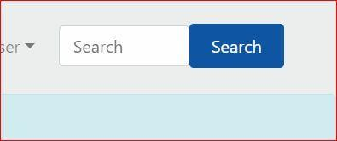

1. Enter a text relating to the post(s) you are looking for and click **Search**. A list of posts, showing the title and excerpts, will be displayed as cards on a results page.
2. Refine your search appropriately to get the specific post, or groups of posts you want. This is where the **tags** and **categories** (that you assigned to the posts when they were created) are useful as search parameters to enable you easily locate your posts.
3. When you have found your post, hover the mouse cursor over the title of the post until it is highlighted.
4. Click the title when it is highlighted or, alternatively, click **Continue Reading** on the card.
5. You will be served with a page giving you the full article of the post.
6. Read the article and make comments, if comments are allowed on the post.

## Recent Post, Recent Comments and Tags cloud

When a post you created is published, it will appear on the **Recent Posts** section of the sidebar is on the right. Recent Posts section displays a list of links to posts recently submitted and published on the site; the number of recently posts listed is based on what we have specified for the site (you will see the **Recent Comments** section as well). The links take to the respective page displaying the content. So if your post appears on the list, such as the recently posted one in a previous section, you do not need to go through the search process describe in the last section.

Also on the sidebar you will see a **Categories** section links list of all the categories that have been used to create posts on the site (Note: The categories list may be put in a dropdown box to conserve space).

Similarly, all the **Tags** (i.e. keywords) used are displayed as links, in a cloud format, in the footer of each page. Both sections may have a count appended in brackets to each category or tag, depending on how the site options are configured.

**Clicking a category link on the sidebar will produce a search result listing all the posts in that are assigned to that category. The same applies when you click a tag link.**

## Edit an existing post

If an existing post has an **Edit** link on the blog list (or within the post itself), it means you are authorized to edit the contents of the post.

* Click the **Edit** link, make the changes you want. You can change/add to the categories, tags, featured image and the content as appropriate.
* Publish it by clicking the **Publish** button at the top right of the editing environment.

### Make a Post Featured

While editing the post, you may want make it a featured post, that is put it in a prominent section/location to attract users attention.

* Check the box labeled **Featured this post** at the bottom of the editing environment.

### Make a Post Sticky

Also, while editing the post, you may want to make it sticky, that is, making it prominent always by placing on top of the blog list.

* Check the box labeled **Stick to the top of the blog** at the top of the right sidebar of the editing environment.

## Upload additional images and files to an existing post

Sometimes when you create an article, you may not have prepared all the images and files you want to attach to it. We have provided a useful tool to allow you to upload additional images and files into existing posts. Just open the post and navigate to the button of the page to see the section **Upload additional images and files**.

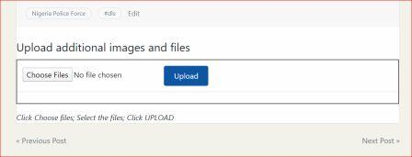

1. Search and locate the post.
2. Enter the post to reveal its article contents, by clicking the title link or the **Continue Reading** button.
3. Scroll down to the **Upload additional images and files** section.
4. Click **Choose Files**.
5. Navigate to the desired folder containing the images or files.
6. Select the file(s). Multiple selections are allowed.
7. Click **Upload**
8. On completion, refresh the page.
9. The new images will appear within the slider.
10. Non-image files are listed as links, which you click to download or view.

## Overview on navigating a website

This chapter serves as appreciation training for interacting with a typical website, especially sites built with WordPress. The navigation procedures are typical for any site and we will assume users are familiar with them from this point on. You can surf the web for more information to enrich your knowledge base.

The procedures explained in this chapter are how DLS management will engage with the public through articles and media published in this way.

# User Registration

## Introducing User Registration

Recall in the introductory chapter that Works Manager Online serves two main purposes, and we have so far dealt with its purpose as a public engagement blog. The second purpose is as a **project monitoring tool**, which is the primary design focus of the site and the focus of this chapter.

To access the project monitoring features of Works Manager Online, you must be registered as a user on the site because these features are exclusive to staff of DLS who are tasked with monitoring, generating and submitting reports on the progress of the contracts.

You must however be registered as a user on the site to expose the features. The registration process and related tasks are described in the following sections.

## Register a User for Works Manager Online Operations

Only those assigned administrative roles that include creating users can register a user, assign them capabilities and editing their profiles.

* Navigation:User Registration => Register a User**.**
* On the page served titled **Register a User**, enter the details required in the fields, and note that the required fields have a red asterix (*) appended to their labels.



1. Enter Username
2. Enter First Name
3. Enter Last Name
4. Enter Email
5. Enter Password
6. Enter Repeat Password. **This must match the password entered in previous step.**
7. Click **Add User**.
8. You will be notified of success or failure on the page you are redirected,
9. On success, an email will be sent to the email address provided in step 4. The new user will be asked to click a link to activate his/her account on Works Manager Online website.
10. The user must access the email account and click the link to be activated.
11. On success activation, the user will be directed to the site.
12. If you are the user, click **Log In** on the menu and enter the **Username** and the **Password** specified in steps 1 and 5, respectively, on the Log In form.

* Note: The administrator would have sent you the password via a secure channel.
* Furthermore, memorise these credentials for future use.

1. On successful login, you will be taken to the home page for **Works Manager Online** operations with the appropriate menu on the menu bar.
2. You are now granted access to the Works Manager Online operations features.
3. Proceed to navigate the site and perform your monitoring operations.

## Log in as a Registered User

If you are a registered user you can log into the site as follows:

* Navigation:Log in**.**

1. Click **Log In** on the menu bar enter your username and password on the Login form.
2. On successful login, you will be taken to the home page for **Works Manager Online** operations with the appropriate menu on the menu bar.
3. You should notice the different home page displayed and the different menus on the menu bar.
4. You are now granted access to the Works Manager Online operations features
5. Proceed to navigate the site and perform your monitoring tasks.

## Edit the profile of a registered user

In cases where a user’s credentials has been compromised, or he/she has lost the password to gain access to Works Manager Online operations, the assigned registration administrator can change the profile of the user.

Navigation:User Registration => Manage Login Profiles**.**

On the page served titled **Manage (Edit) Login profiles**, modify the profile details as required.



1. Select the User to Edit
2. Change any of the details on the form as required. **The Username cannot be changed !**
3. Change First Name
4. Change Last Name
5. Change Email
6. Enter Password
7. Enter Repeat Password
8. Click **Update**
9. Inform the user of the changes. If password was changed, send it via a secure channel.

## Log out of the site.

* Navigation: User Registration =>Log Out**.**

1. You will be taken to a form that tells you that you are lagged in.
2. Click the **Log Out** link.
3. You will be redirected to the Public Engagement Blog home page.

## Rules of User Engagement

* Visitors to the site cannot register themselves.
* Registered Users’ are created by administrators of the site based on request that have been approved by the delegated authority.
* Users’ cannot change their profile. This must be done by the delegated authority.
* If a user’s profile is compromised in any way, he/she must inform delegated authority to block access using the credentials.

# Command and Zone Assignments

## The purpose of Command and Zone Assignments

When a user is newly registered and is logged in to the site, the only Works Manager Online role the user can perform at that stage is to view the contracts and report details and search. The primary function of submitting reports on the progress of contracts is not granted to a newly registered user simply upon registration. Another layer of role assignments to the user is required to grant this capability. Users requiring such capability are primarily the **Works Officers** and **Project Officers**.

The **User Management and Operational Data** facility is where these users are granted the required roles to submit reports on the groups of contracts on their schedule.

This chapter deals with granting and revoking users the authority to submit reports on contracts. The basis is that Works Officers and Project Officers are assigned supervisory roles over contracts based on the Command and Zone structure of the Nigeria Police Force. After the NPF awards contracts, they are sited in, and managed according to, the Command and Zone structure of the Force. Accordingly, officers are assigned contracts in a command or zone to supervise. This assignment is done in the **Command and Zone Assignments** section.

The screenshots below show the relevant operations and a typical form template to make the assignments.

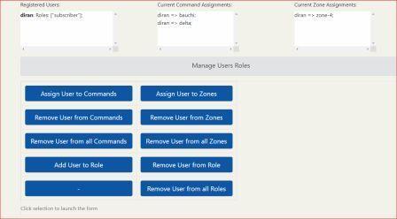

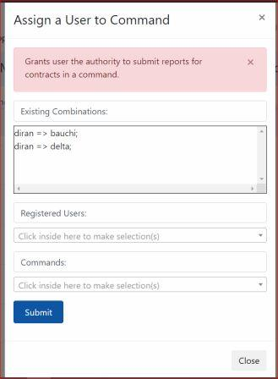

## Assign a User to a Command

Navigation:

* Works Manager Online =>User Management and Operational Data**.**
* Then click **Assign User to Commands**.
* A form will pop up showing the list of existing User – Command assignments.

To assign a user to a command;

1. Select a user from the **Registered Users** dropdown box list.
2. Select a command from the **Commands** dropdown box list.
3. Click **Submit**. You will be prompted accordingly.
4. The assignment will be reflected in the list of existing User – Command assignments.

The user is now granted authority to submit reports on any of the contracts in the command assigned.

To confirm this, do the following.

1. Ask the user assigned the command to login.
2. Locate a contract post in the command.
3. Enter the contract post.
4. A prominent button (in a prominent color blue) should be activated. The button is labeled

**Click here to select a form, fill it and submit. Options will appear below!**

1. Click the button to display the various report templates that are available.
2. The user can select a template, fill the form and submit.
3. This verifies the process was successful.

## Assign a User to a Zone

Navigation:

* Works Manager Online =>User Management and Operational Data**.**
* Then click **Assign User to Zones**.
* A form will pop up showing the list of existing User – Zones assignments.

To assign a user to a zone;

1. Select a user from the **Registered Users** dropdown box list.
2. Select a zone from the **Zone** dropdown box list.
3. Click **Submit**. You will be prompted accordingly.
4. The assignment will be reflected in the list of existing User – Zone assignments.

The user is now granted authority to submit reports on any of the contracts in the zone assigned.

To confirm this, do the following.

1. Ask the user assigned the zone to login.
2. Locate a contract post in the zone.
3. Enter the contract post.
4. A prominent button (in a prominent color blue) should be activated. The button is labeled

**Click here to select a form, fill it and submit. Options will appear below!**

1. Click the button to display the various report templates that are available.
2. The user can select a template, fill the form and submit.
3. This verifies the process was successful.

## Remove a User from a Command

Navigation:

* Works Manager Online =>User Management and Operational Data**.**
* Then click **Remove User from Commands**.
* A form will pop up showing the list of existing User – Command assignments.

To remove a user from a command;

1. Select a user from the **Registered Users** dropdown box list.
2. Select a command from the **Commands** dropdown box list.
3. Click **Submit**. You will be prompted accordingly.
4. The removal will be reflected in the list of existing User – Command assignments.

The user’s authority to submit reports has been revoked on any of the contracts in the command assigned.

To confirm this, do the following.

1. Ask the user to login.
2. Locate a contract post in the command revoked.
3. Enter the contract post.
4. The prominent button (in a prominent color blue) should have been de-activated.
5. This verifies the revocation process was successful.

## Remove a User from a Zone

Navigation:

* Works Manager Online =>User Management and Operational Data**.**
* Then click **Remove User from Zones**.
* A form will pop up showing the list of existing User – Zone assignments.

To remove a user from a command;

1. Select a user from the **Registered Users** dropdown box list.
2. Select a zone from the **Zones** dropdown box list.
3. Click **Submit**. You will be prompted accordingly.
4. The removal will be reflected in the list of existing User – Zone assignments.

The user’s authority to submit reports has been revoked on any of the contracts in the zone assigned.

To confirm this, do the following.

1. Ask the user to login.
2. Locate a contract post in the zone revoked.
3. Enter the contract post.
4. The prominent button (in a prominent color blue) would have been de-activated.
5. This verifies the revocation process was successful.

## Remove a User from all Commands

Navigation:

* Works Manager Online =>User Management and Operational Data**.**
* Then click **Remove User from all Commands**.
* A form will pop up showing the list of existing User – Command assignments.

To remove a user from all commands;

1. Select a user from the **Registered Users** dropdown box list.
2. Click **Submit**. You will be prompted accordingly.
3. The removal will be reflected in the list of existing User – Command assignments.

The user’s authority to submit reports has been revoked on any contracts in commands.

To confirm this, do the following.

1. Ask the user to login.
2. Locate a contract post from any of the revoked commands.
3. Enter the contract post.
4. The prominent button (in a prominent color blue) would have been de-activated.
5. Repeat this process for a variety of contracts in the relevant commands.
6. This verifies the revocation process was successful.

## Remove a User from all Zones

Navigation:

* Works Manager Online =>User Management and Operational Data**.**
* Then click **Remove User from all Zones**.
* A form will pop up showing the list of existing User – Zone assignments.

To remove a user from all zones;

1. Select a user from the **Registered Users** dropdown box list.
2. Click **Submit**. You will be prompted accordingly.
3. The removal will be reflected in the list of existing User – Zone assignments.

The user’s authority to submit reports has been revoked on any contracts in all zones.

To confirm this, do the following.

1. Ask the user to login.
2. Locate a contract post from any of the revoked zones.
3. Enter the contract post.
4. The prominent button (in a prominent color blue) would have been de-activated.
5. Repeat this process for a variety of contracts in the relevant zones.
6. This verifies the revocation process was successful.

## Overview of Command and Zones Assignments

The processes described in this chapter forms the second layer of protection of information concerning contracts by adding extra credibility and value to the projects monitoring information from the website. The next chapter will describe the third layer, which assigns operational roles to users.

# Role Assignments

## Concept of Role Assignments

The processes described here are role assignments designed to grant authority to submitting reports on contracts based on the hierarchy and designation of officers who are registered. The system is based on custom defined roles such as Works Officers, Project Officers and Force Works Officer, for example. Each custom role is assigned permissions/capabilities such as authority to publish posts and submit reports, and the capabilities granted are dependent on the command and zone assignments to take effect.

For example, the rule currently in force on the site is that only users with Works Officers role can submit reports on contracts and this takes effect only if the officer has command and zone assignments. Conversely, if the user is given command/zone assignments, the user still requires Works Officer role to be able to submit reports on those contracts in his/her command/zone assignments.

This model is based on the assumption that Works Officers who regularly visit the contracts sites are those that should generate progress reports on the contracts. A comprehensive review of procedures will define in more granular detail the philosophy of the rules of engagement as regards roles and capabilities assignments to users.

The **Roles Assignment** feature is integrated with the Command and Zone Assignments as the screenshot below shows, and the typical form template to make the assignments.



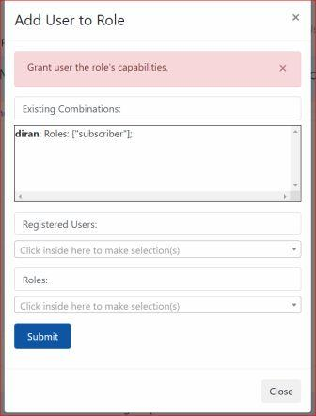

## Add Role to a User

Navigation:

* Works Manager Online =>User Management and Operational Data**.**
* Then click **Add Role to User**.
* A form will pop up showing the list of existing User – Role assignments.

To assign a role to a user;

1. Select a user from the **Registered Users** dropdown box list. Please, select a user with existing command or zone assignment(s), for tutorial purposes.
2. Select a role (**Works Officers**) from the **Roles** dropdown box list.
3. Click **Submit**. You will be prompted accordingly.
4. The assignment will be reflected in the list of existing User – Role assignments.

The user is now granted authority to submit reports on any of the contracts in the commands/zones assigned.

To confirm this, do the following.

1. Ask the user to login.
2. Locate a contract post in the assigned command/zone.
3. Enter the contract post.
4. A prominent button (in a prominent color blue) would be activated. The button is labeled

**Click here to select a form, fill it and submit. Options will appear below!**

1. Click the button to display the various report templates that are available.
2. The user can select a template, fill the form and submit.
3. This verifies the process was successful.

## Remove Role from a User

Navigation:

* Works Manager Online =>User Management and Operational Data**.**
* Then click **Remove Role from User**.
* A form will pop up showing the list of existing User – Role assignments.

To remove a user from a role;

1. Select a user from the **Registered Users** dropdown box list. Please, select a user with existing command or zone assignments, for tutorial purposes.
2. Select a role (**Works Officers**) from the **Roles** dropdown box list.
3. Click **Submit**. You will be prompted accordingly.
4. The assignment will be reflected in the list of existing User – Role assignments.

The user’s authority to submit reports is revoked on any of the contracts in the commands/zones assigned.

To confirm this, do the following.

1. Ask the user to login.
2. Locate a contract post in the assigned command/zone.
3. Enter the contract post.
4. The prominent button (in a prominent color blue) would be de-activated.
5. This verifies the process was successful.

## Remove all Roles from a User

Navigation:

* Works Manager Online =>User Management and Operational Data**.**
* Then click **Remove all Roles from a User**.
* A form will pop up showing the list of existing User – Role assignments.

To remove a user from a role;

1. Select a user from the **Registered Users** dropdown box list. Please, select a user with existing command or zone assignments, for tutorial purposes.
2. Click **Submit**. You will be prompted accordingly.
3. The assignment will be reflected in the list of existing User – Role assignments.

The user’s authority to submit reports is revoked on any of the contracts in the commands/zones assigned, in fact the user is reverted back to the status of a newly registered user.

To confirm this, do the following.

1. Ask the user to login.
2. Locate a contract post in the assigned command/zone.
3. Enter the contract post.
4. The prominent button (in a prominent color blue) would be de-activated.
5. Repeat this confirmation process for a variety of contracts.
6. This verifies the process was successful.

## Overview of Role Assignments – The required credentials

The role assignments described in this chapter is the third layer of security for protecting the credibility of the project monitoring functions that Works Manager Online is designed to assist.

**The current credentials required for a user to be able to submit progress reports are as follows;**

1. **The user must be a Registered User.**
2. **The user must have Works Officers role.**
3. **The user must have at least one command or zone assigned.**

Without these credential, you are only a visitor restricted to the Public Engagement Blog.

# Operational Data

## Introducing the Operational Data concept

**Operational Data** in Works Manager Online are the options that will be available for selection to enhance the details of your report on the various reports template forms. For example, **Site** report template is where you describe the various types of issues the contracts could be experiencing while executing the work. **Site Issues** facility described subsequent sections is where you define the options to categorise the Site report, and your definitions will appear for selection when you are filling the Site report.

The screenshots below describe the subject matters currently available as options to be defined. Below it is a typical template to enter the options.

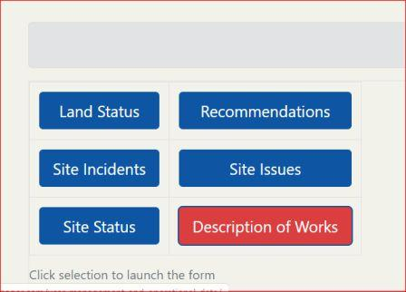

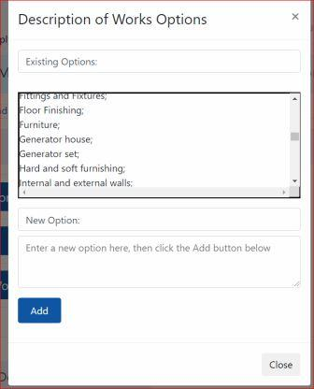

## Description of Works

Navigation:

* Works Manager Online =>User Management and Operational Data**.**
* Scroll to the section **Managing Operational Data**.
* Then click **Description of Works**.
* A form will pop up showing the list of existing options.

To add a new option

1. Enter your new option in **New Option** text area.
2. Click **Add**.
3. The option will be added and would reflect on the list.
4. The option will now be available for selection when the **Monthly Progress** Report form is being filled.

## Land Status

Navigation:

* Works Manager Online =>User Management and Operational Data**.**
* Scroll to the section **Managing Operational Data**.
* Then click **Land Status**.
* A form will pop up showing the list of existing options.

To add a new option

1. Enter your new option in **New Option** text area.
2. Click **Add**.
3. The option will be added and would reflect on the list.
4. The option will now be available for selection when the **Land Acquisition** Report form is being filled.

## Recommendations

Navigation:

* Works Manager Online =>User Management and Operational Data**.**
* Scroll to the section **Managing Operational Data**.
* Then click **Recommendations**.
* A form will pop up showing the list of existing options.

To add a new option

1. Enter your new option in **New Option** text area.
2. Click **Add**.
3. The option will be added and would reflect on the list.
4. The option will now be available for selection when the **Monthly Progress** Report form is being filled.

## Site Incidents

Navigation:

* Works Manager Online =>User Management and Operational Data**.**
* Scroll to the section **Managing Operational Data**.
* Then click **Site Incidents**.
* A form will pop up showing the list of existing options.

To add a new option

1. Enter your new option in **New Option** text area.
2. Click **Add**.
3. The option will be added and would reflect on the list.
4. The option will now be available for selection when the **Incident Report** form is being filled.

## Site Issues

Navigation:

* Works Manager Online =>User Management and Operational Data**.**
* Scroll to the section **Managing Operational Data**.
* Then click **Site Issues**.
* A form will pop up showing the list of existing options.

To add a new option

1. Enter your new option in **New Option** text area.
2. Click **Add**.
3. The option will be added and would reflect on the list.
4. The option will now be available for selection when the **Site** Report form is being filled.

## Site Status

Navigation:

* Works Manager Online =>User Management and Operational Data**.**
* Scroll to the section **Managing Operational Data**.
* Then click **Site Status**.
* A form will pop up showing the list of existing options.

To add a new option

1. Enter your new option in **New Option** text area.
2. Click **Add**.
3. The option will be added and would reflect on the list.
4. The option will now be available for selection when the **Site** Report form is being filled.

## Upload Contracts Information to Works Manager Online Website

**Works Manager** **Online** gets its contracts details from the **Works Manager** desktop application where details of the contract and award documentation are stored. When a contract is awarded to a contractor, the details of that contract stored Works Manager are uploaded to the **Works Manager Online** website ready for monitoring from when contractor moves to site to completion of the contract.

To upload contracts details to Works Manager Online website, download the details of the contracts that need to be monitored from the Works Manager desktop application. The download must be in .xml format.

Upload the details following the steps below

Navigation:

* Works Manager Online =>User Management and Operational Data**.**

1. Scroll to the section **Upload Contracts Details**.
2. Then click **Choose File**.
3. Navigate to the desired folder containing the .xml.
4. Select the file.
5. Click **Upload Contracts**.
6. When the upload completes, navigate to Works Manager Online =>Contracts.
7. The contracts details you just uploaded should be on the list.
8. You can search to confirm.

## Review of Operational Data

The procedures described in this chapter are where appropriate and credible information are defined to enhance the quality of the reports submitted online. It is expected that management invest time to create the definition of the options to ensure consistency in the reports. Furthermore, the options defined here automatically become parameters you can use for your search on the website.

# The Contracts Blog and The Reports Blog

## Contracts Blog and Reports Blog Explained

This chapter describes the procedures to search and navigate around the databank of contracts and their reports. This feature is one where registered users will mostly be engaging. The **Contracts Blog** and the **Reports Blog** are organised as separate **blogs**, or **blog** lists, in different sections under a menu through which management can search through, view and read reports to keep track of the progress of contracts.

## Contracts Blog

The **Contracts Blog** is the list of posts of all the contracts details on the site. The contracts are listed in card format with the title, location details and excerpts, displayed, with its featured image, if it exists.

* Navigation: Works Manager Online => Contracts.

1. This lists the contracts as cards with excerpts of the title and description.
2. Scroll down to see more contracts.
3. At the end of the page, you can navigate to other pages via the pagination linksto reveal more by clicking on the page you want or navigate page by page.
4. Note the information on the sidebar. It includes a list of the Latest Reports, which are also displayed on a slider below the list.
5. Scrolling down further you will see sections on the sidebar such as Contract Types, Commands and Zones, for example, with their corresponding categorizations as links and numbers in brackets indicating the count of the contracts under the category.
6. Click the link of any category to show the list of contracts under that category. For example, if you click **Rehabilitation**, the list of all rehabilitation contracts details stored in the website will be displayed.

## Contract Post

The **Contract Post** is the details of a contract and the article inside the post is the description of that contract.

* Navigation: Works Manager Online => Contracts.

1. Search/Scroll to the contract of interest.
2. Click the title link or **Continue Reading** on your selected one.
3. The contracts post page will display containing the description and other relevant details.

The contract post typically consists of the following

* the title of the contract,
* a button to expose reports templates that you can select, fill and submit for the contract,
* a slider that slides through the existing reports previously created for the contract and
* a table listing the existing reports previously created for the contract

## Contract Post's Reports Templates

These are the various report templates currently available for filling and submitting for monitoring purposes. You can see these templates by following the steps.

* Navigation: Works Manager Online => Contracts.

1. Scroll to the contract of interest.
2. Click the title link or **Continue Reading** on your selection.
3. The contracts post will be displayed.
4. Locate the button **Click here to select a form, fill it and submit. Options will appear below!**
5. This will expand to reveal the reports template tab with the following template choices:

* [Monthly Progress](http://live-worksmanager.pantheonsite.io/wrksmgr_contracts/f-487-2007-supply-of-hard-and-soft-furniture-at-police-trainning-school-oyin-akoko-in-ondo-state/#tab1)
* [Site](http://live-worksmanager.pantheonsite.io/wrksmgr_contracts/f-487-2007-supply-of-hard-and-soft-furniture-at-police-trainning-school-oyin-akoko-in-ondo-state/#tab2)
* [Interim](http://live-worksmanager.pantheonsite.io/wrksmgr_contracts/f-487-2007-supply-of-hard-and-soft-furniture-at-police-trainning-school-oyin-akoko-in-ondo-state/#tab3)
* [Incident](http://live-worksmanager.pantheonsite.io/wrksmgr_contracts/f-487-2007-supply-of-hard-and-soft-furniture-at-police-trainning-school-oyin-akoko-in-ondo-state/#tab4)
* [Investigation](http://live-worksmanager.pantheonsite.io/wrksmgr_contracts/f-487-2007-supply-of-hard-and-soft-furniture-at-police-trainning-school-oyin-akoko-in-ondo-state/#tab5)
* [Completion](http://live-worksmanager.pantheonsite.io/wrksmgr_contracts/f-487-2007-supply-of-hard-and-soft-furniture-at-police-trainning-school-oyin-akoko-in-ondo-state/#tab6)
* [Land Acquisition](http://live-worksmanager.pantheonsite.io/wrksmgr_contracts/f-487-2007-supply-of-hard-and-soft-furniture-at-police-trainning-school-oyin-akoko-in-ondo-state/#tab7)
* [Special Visits](http://live-worksmanager.pantheonsite.io/wrksmgr_contracts/f-487-2007-supply-of-hard-and-soft-furniture-at-police-trainning-school-oyin-akoko-in-ondo-state/#tab8)

This tab area is where the main function of submitting progress reports on contracts will be done.

## Search Contracts – Basic Search and Advanced Search engines

There will be many contracts details stored on the website, and you will need to locate specific contracts or a group of contracts for your work. A custom search engine specific to the attributes of contracts is provided in two forms, as **Basic Contracts Search** and **Advanced Contracts Search**.

### Basic Contracts Search

With Basic Contracts Search you can search by Lot Number, Year (of award) and Contracts Type.

* Navigation: Works Manager Online => Basic Contracts Search.
* This will display the **Basic Contract Search** page.

1. To search for a specific lot, select the lot from the **Lot Number** dropdown list.
2. Click **Search** button.
3. The number of items matching the criteria, and the corresponding list, will be displayed.
4. Scroll down to see the results. Advance to other pages if necessary by clicking pagination links.
5. Alternatively, select the **Year** or **Contract Type** or a **combination** of both
6. Repeat from Step 2.

### Advanced Contract Search

With Advanced Contract Search, the search options are extended with Zone, Command, State and Local Government as search options. This provides the ability to make finer searches from the list of contracts.

* Navigation: Works Manager Online => Advanced Contracts Search.
* This will display the **Advanced Contract Search** page.

1. To search for a specific Lot No, Select the lot from the **Lot Number** dropdown list.
2. Click **Search** button.
3. The number of items found, and the corresponding list, will be displayed.
4. Scroll down to see the results. Advance to other pages if necessary
5. Alternatively, select **either**
6. Year
7. Contract Type
8. Zone
9. Command
10. State
11. Local Government
12. Or any combination of the six options
13. Repeat from Step 2.

## Contracts Assigned to a Registered User

If you are a registered user and have been assigned the credentials consisting of command and/or zone assignments, then you can go directly to a page list all the contracts in your schedule.

* Navigation: Works Manager Online => Contracts Assigned to You.
* Or Navigation: User Registration => My Profile;
* Or User Profile => My Profile, depending on you menu bar
* This will display the **Contract Assigned to You** page, showing your credentials, command assignments, zone assignments and the corresponding list of contracts you are authorised to monitor.

## Reports Blog

The **Reports Blog** is the list of posts of all the reports that have been created on all contracts. The report are listed in card format with the title, brief of the contract’s details and excerpts of the report, displayed on the card.

**The card for each report must show an image because it is a requirement when creating reports to set a featured image, which should reflect the context and subject of the report.**

* Navigation: Works Manager Online => Reports.

1. This lists the reports as cards with excerpts of the title and description.
2. Scroll down to see more reports.
3. At the end of the page, you can navigate to other pages to reveal more by clicking on the page you want or navigate page by page.
4. Note also the information on the sidebar. It includes a list of the Latest Reports, which are also displayed on a slider below the list.
5. Scrolling down further you will see sections on the sidebar such as Report Types and Report Years, for example, with their corresponding categorizations.
6. Click the link of any of the categories and it will show the list of reports under this category. For example, if you click Progress Report, a list of all progress reports will be displayed.

## Report Post

The **Report Post** is the details of reports submitted for the contract. The article inside the post is the information provided by the user when the report was created and submitted through one of the report templates of the contract post.

* Navigation: Works Manager Online => Reports.

1. Scroll to the report of interest.
2. Click the title link or **Continue Reading** on your selected one.
3. The report post will display.

The Report Post consists of the

* title of the report,
* description of the report, combined from entries in the report’s template,
* an image slider that automatically slides through the pictures submitted with the report and
* a table listing of the non-image documents, such as text files, pdf files, videos and spreadsheets, attached to the report.

## Search Reports

There will also be many reports on contracts stored on the website, and you will need to locate specific reports or a group of reports. A custom search engine specific to the attributes of reports is provided.

* Navigation: Works Manager Online => Reports.
* This will display the **Reports Search** page.

1. To search for the report for a specific contract lot, select the lot from the **Lot Number** dropdown list.
2. Click **Search** button.
3. The number of items found, and the corresponding list, will be displayed.
4. Scroll down to see the results. Advance to other pages if necessary
5. Alternatively, select **either**
6. **Contract** **Year**
7. **Report Type**
8. **Report Year**
9. or any **combination** of the three options above.
10. Repeat from Step 2.

## Review of Contracts and Reports Blog

In essence the Contracts Blog and Reports Blog together form the core feature of Works Manager Online. They form the basis of the relevance of the website as regards project monitoring. From the Contract Post, all the activities of a contract in terms of submitted reports can be viewed.

# Monitoring the Progress of Contracts – Submitting Reports on Contracts

## Recap of the motivation for Works Manager Online.

The premise for building **Works Manager Online** include reducing projects life cycles, assure improved contracts completion rates and, above all, eliminate incomplete and abandoned projects embarked on by the Nigeria Police Force. **Works Manager Online** is, therefore, designed as a **project monitoring tool** to monitor the progress of their infrastructure projects across the various police commands nationwide by transmitting contracts progress information (pictures, videos, written documents) via the Internet.

Therefore, a major activity that will be done through the website is generating reports and submitting them online together with supporting attachments, like pictures and videos, that capture the progress of the contracts. Written documents in electronic formats can also be attached to the online reports that are submitted from the website. Staff responsible for monitoring contracts can perform these functions from their respective stations, and in situ at the contracts’ sites, from any location in the country.

This section describes how to generate and submit online reports for the ongoing contracts through predefined forms templates. The forms are simple, concise and easy to fill and attach documents and pictures just like you do when you send information by email. **Submissions of reports are done through the Contract Post**.

## Submit Monthly Progress Report

* Navigation: Works Manager Online => Contracts.
* Note: You may search for, or locate, the contract by the several means described in previous chapters.

1. Select the contract of interest.
2. Enter the contract post by clicking the title link or the **Continue Reading** button.
3. Click the button labeled **Click here to select a form, fill it and submit. Options will appear below!**
4. Examine the tab displaying the various report templates that are available.
5. Select **Monthly Progress** on the tab.
6. Patiently, enter relevant information in the fields on the form.
7. Report Title
8. Description
9. Milestones/Work done.
10. Your Recommendations.
11. Any other details to help decision making
12. Select pictures, if any, to upload with your report.
13. Select one (only)of your pictures to feature on your report
14. Select videos to upload, if any, with your report.
15. Select written reports, if any, with your report
16. After completing your entries, review your entries. To assist in determining that you have supplied the required information, you are required to tick the checkboxes at the end of form.

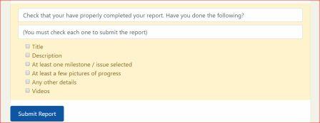

1. Click **Submit** **Report**.
2. You will be notified on success of failure of the submission.
3. If you refresh the page, the report will appear on the slider and as a link on the list below the slider.

## Submit Site Report

* Navigation: Works Manager Online => Contracts.
* Note: You may search for, or locate, the contract by the several means discussed in previous chapters

1. Select the contract of interest.
2. Enter the contract post by clicking the title link or the **Continue Reading** button.
3. Click the button labeled **Click here to select a form, fill it and submit. Options will appear below!**
4. Examine the tab displaying the various report templates that are available.
5. Select **Site** on the tab.
6. Patiently, enter relevant information in the fields on the form.
7. Report Title
8. Site Issues.
9. Description
10. Status of Site.
11. Give any other details you feel necessary to help decision making,
12. Select pictures, if any, to upload with your report.
13. Select one (only)of your pictures to feature on your report
14. Select videos to upload, if any, with your report.
15. Select written reports, if any, with your report
16. After completing your entries, review your entries. To assist in determining that you have supplied the required information, you are required to tick the checkboxes at the end of form.



1. Click **Submit** **Report**.
2. You will be notified on success of failure of the submission.
3. If you refresh the page, the report will appear on the slider and as a link on the list below the slider.

## Submit Interim Report

* Navigation: Works Manager Online => Contracts.
* Note: You may search for, or locate, the contract by the several means discussed in previous chapters

1. Select the contract of interest.
2. Enter the contract post by clicking the title link or the **Continue Reading** button.
3. Click the button labeled **Click here to select a form, fill it and submit. Options will appear below!**
4. Examine the tab displaying the various report templates that are available.
5. Select **Interim** on the tab.
6. Patiently, enter relevant information in the fields on the form.
7. Report Title
8. Description
9. Select pictures, if any, to upload with your report.
10. Select one (only)of your pictures to feature on your report
11. Select videos to upload, if any, with your report.
12. Select written reports, if any, with your report
13. After completing your entries, review your entries. To assist in determining that you have supplied the required information, you are required to tick the checkboxes at the end of form.



1. Click **Submit** **Report**.
2. You will be notified on success of failure of the submission.
3. If you refresh the page, the report will appear on the slider and as a link on the list below the slider.

## Submit Incident Report

* Navigation: Works Manager Online => Contracts.
* Note: You may search for, or locate, the contract by the several means discussed in previous chapters

1. Select the contract of interest.
2. Enter the contract post by clicking the title link or the **Continue Reading** button.
3. Click the button labeled **Click here to select a form, fill it and submit. Options will appear below!**
4. Examine the tab displaying the various report templates that are available.
5. Select **Incident** on the tab.
6. Patiently, enter relevant information in the fields on the form.
7. Report Title
8. Incident Types.
9. Comprehensive Description of Incidents.
10. Select pictures, if any, to upload with your report.
11. Select one (only)of your pictures to feature on your report
12. Select videos to upload, if any, with your report.
13. Select written reports, if any, with your report
14. After completing your entries, review your entries. To assist in determining that you have supplied the required information, you are required to tick the checkboxes at the end of form.



1. Click **Submit** **Report**.
2. You will be notified on success of failure of the submission.
3. If you refresh the page, the report will appear on the slider and as a link on the list below the slider.

## Submit Investigation Report

* Navigation: Works Manager Online => Contracts.
* Note: You may search for, or locate, the contract by the several means discussed in previous chapters

1. Select the contract of interest.
2. Enter the contract post by clicking the title link or the **Continue Reading** button.
3. Click the button labeled **Click here to select a form, fill it and submit. Options will appear below!**
4. Examine the tab displaying the various report templates that are available.
5. Select **Investigation** on the tab.
6. Patiently, enter relevant information in the fields on the form.
7. Report Title
8. Give details of your investigations
9. Milestones/Work done.
10. Your assessment and recommendations.
11. Give any other details you feel necessary to help decision making.
12. Select pictures, if any, to upload with your report.
13. Select one (only)of your pictures to feature on your report
14. Select videos to upload, if any, with your report.
15. Select written reports, if any, with your report
16. After completing your entries, review your entries. To assist in determining that you have supplied the required information, you are required to tick the checkboxes at the end of form.



1. Click **Submit** **Report**.
2. You will be notified on success of failure of the submission.
3. If you refresh the page, the report will appear on the slider and as a link on the list below the slider.

## Submit Completion Report

* Navigation: Works Manager Online => Contracts.
* Note: You may search for, or locate, the contract by the several means discussed in previous chapters

1. Select the contract of interest.
2. Enter the contract post by clicking the title link or the **Continue Reading** button.
3. Click the button labeled **Click here to select a form, fill it and submit. Options will appear below!**
4. Examine the tab displaying the various report templates that are available.
5. Select **Completion** on the tab.
6. Patiently, enter relevant information in the fields on the form.
7. Report Title
8. Description
9. Status of site on completion..
10. Select pictures, if any, to upload with your report.
11. Select one (only)of your pictures to feature on your report
12. Select videos to upload, if any, with your report.
13. Select written reports, if any, with your report
14. After completing your entries, review your entries. To assist in determining that you have supplied the required information, you are required to tick the checkboxes at the end of form.



1. Click **Submit** **Report**.
2. You will be notified on success of failure of the submission.
3. If you refresh the page, the report will appear on the slider and as a link on the list below the slider.

## Submit Land Acquisition Report

* Navigation: Works Manager Online => Contracts.
* Note: You may search for, or locate, the contract by the several means discussed in previous chapters

1. Select the contract of interest.
2. Enter the contract post by clicking the title link or the **Continue Reading** button.
3. Click the button labeled **Click here to select a form, fill it and submit. Options will appear below!**
4. Examine the tab displaying the various report templates that are available.
5. Select **Land Acquisition** on the tab.
6. Patiently, enter relevant information in the fields on the form.
7. Report Title
8. Description
9. Status of Land
10. Select pictures, if any, to upload with your report
11. Select one (only)of your pictures to feature on your report
12. Select videos to upload, if any, with your report
13. Select written reports, if any, with your report
14. After completing your entries, review your entries. To assist in determining that you have supplied the required information, you are required to tick the checkboxes at the end of form.



1. Click **Submit** **Report**.
2. You will be notified on success of failure of the submission.
3. If you refresh the page, the report will appear on the slider and as a link on the list below the slider.

## Submit Special Visits Report

* Navigation: Works Manager Online => Contracts.
* Note: You may search for, or locate, the contract by the several means discussed in previous chapters

1. Select the contract of interest.
2. Enter the contract post by clicking the title link or the **Continue Reading** button.
3. Click the button labeled **Click here to select a form, fill it and submit. Options will appear below!**
4. Examine the tab displaying the various report templates that are available.
5. Select **Special Visits** on the tab.
6. Patiently, enter relevant information in the fields on the form.
7. Report Title
8. Describe the visit in detail.
9. Select pictures, if any, to upload with your report
10. Select one (only)of your pictures to feature on your report
11. Select videos to upload, if any, with your report
12. Select written reports, if any, with your report
13. After completing your entries, review your entries. To assist in determining that you have supplied the required information, you are required to tick the checkboxes at the end of form.



1. Click **Submit** **Report**.
2. You will be notified on success of failure of the submission.
3. If you refresh the page, the report will appear on the slider and as a link on the list below the slider.

## Review of Monitoring the Progress of Contracts

The main activity is filling the appropriate form templates, attach pictures and other document types to the report to enhance its value and then submit it. More report types templates can be added as required by the department. Note that the report templates are similar and are a one – page jobs to avoid filling of the forms being cumbersome. In fact, the pictures are of great value to be supported by brief and concise decisions. The limit for the number of pictures and documents that can be uploaded with a report can be changed on request.

# Archives

## Site-Wide Archives

This is a page showing the summary of all the content in the website. It is a dashboard of the content of the site. The page summaries all the posts organise by their categories, authors, tags. The summary for contracts and reports are also shown organised by year, report types, contract types, zone, commands, state and local government. Each piece if information displayed are links to the corresponding content.

To appreciate this page, navigate to Works Manager Online => Site-Wide Archives.

You can go directly to content by clicking the appropriate link.

# Appendix

## About Us

Information about the Nigeria Police Force Department of Logistics and Supply. Click the link on the footer of any page on the site.

## Contact Us

Contact for our visitors. Click the link on the footer of any page on the site.

## Your Feedback

Form for visitors to give us feedback on our site. Click the link on the footer of any page on the site.

## License

License Policy. the link in the footer of any page on the site. Click the link on the footer of any page on the site.

## Privacy Policy

This displays our private policy page. Click the link on the footer of any page on the site.

## Vendor and Credits

Information on the vendor and credits to sources used for build this website. Click the link on the footer of any page on the site.

## Frequently Asked Questions (FAQs)

### How do I see my contracts?

### What do I do if I cannot remember my user name and password?

### What do I do if some of my contracts are not listed?

### Why can I not submit reports for contracts assigned to me?

### How can I block a user totally from gaining any form of access to Works Manager Online?